FOR IMMEDIATE RELEASE
Contact: Craig Mohre
614.939.8150
CraigMohre@newalbanyfoundation.org

Oscar Nominated Actor America Ferrera to Open 12th Season of New Albany Lecture Series Season on October 10th

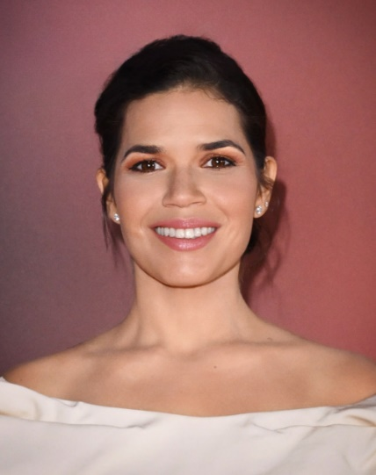
[NEW ALBANY, OH, September 4, 2024] – Tickets for the 12th season of The New Albany Community Foundation’s nationally recognized New Albany Lecture Series will go on sale to the public at 10am ET on September 5. Tickets information is available at newalbanyfoundation.org.

The New Albany Lecture Series will feature Oscar-nominated actor, producer and director, America Ferrera, for its opening program on October 10th. Ferrera is known for her iconic roles, most recently Greta Gerwig’s history-making Barbie, for which she was nominated for an Academy Award®. For her breakthrough performance in Ugly Betty, Ferrera was awarded an Emmy®, a Screen Actors Guild Award®, and a Golden Globe®. Ferrera will be interviewed by NPR West’s Mandalit del Barco with a focus on mental health and Ferrera’s journey in the entertainment industry. Ferrera’s appearance is made possible through support from Sara and Rick Mershad, New Albany residents and philanthropists who are strong health and well-being advocates. The couple previously sponsored Dr. Deepak Chopra’s 2022 visit to New Albany and his participation in The New Albany Lecture Series.
America Ferrera
Photo credit Karwal Tang

In addition to America Ferrera, the 2024-2025 New Albany Lecture Series Season lineup includes a timely discussion on artificial intelligence with AI pioneers Tom Gruber and Zack Kass in conversation moderated by journalist Molly Wood.

In February, former Senators Claire McCaskill and Ben Sasse will come together for another program made possible by The New Albany Center for Civil Discourse and Debate, which was established six years ago by The Barbara and Philip Derrow Family Foundation to promote civil discussion. The program will be moderated by ABC News Anchor Linsey Davis. In March, the national security program will feature Ambassador Susan Rice and former NATO Commander Admiral James Stavridis in conversation moderated by three-time Pulitzer Prize winner and bestselling author David Sanger.

The season will conclude in April with an environmental sustainability discussion featuring Todd Brady, Vice President, Community Relations & Sustainable Operations and Chief Sustainability Officer of Intel Corporation.

The New Albany Lecture Series has presented more than 60 compelling speakers since the series debuted. It is widely recognized as one of the premier lecture series in the country, not only for the caliber of speakers and the topics covered, but also for the Student Lecture Series that has hosted 34,500+ students representing 50 central Ohio schools.

“We’re so grateful to our sponsors and everyone in the community who supports The New Albany Lecture Series,” said Craig Mohre, President of the New Albany Community Foundation. “Each year we are able to bring respected thought leaders who address timely issues being discussed in classrooms and at the dinner table. This year we are excited to add a lecture on artificial intelligence, as the industry continues to grow and become more impactful in our daily lives. With the support of our sponsors, we can bring this quality programming to New Albany as well as invite students from area high schools to participate in The New Albany Student Lectures.”

Sponsors of the 2024-2025 New Albany Lecture Series include Special Program Underwriters: Mershad Family Foundation, The Barbara W. & Philip R. Derrow Family Foundation; Season Sponsors: Abercrombie & Fitch Co., American Electric Power Foundation, Battelle, Encova Insurance; The New Albany Lecture Series Endowment Fund Supporters: Donna & Nick Akins Fund, Archer Family Fund, Karen & Irving Dennis Family Fund, Ben W. Hale Jr. Memorial Fund, Redgrave Family Fund, Ryan Family Fund, Lynne & Steve Smith Family Fund, Leslie H. Wexner New Albany Lecture Series Fund, Wolman Family Fund; Speaker Sponsors: Amgen, Anonymous Donors, CAS, IBP, J.P.Morgan Private Bank, Microsoft, M/I Homes, The Ohio State University, Safelite AutoGlass, Michael & Nanette Triplett Family Fund; Premier Sponsors: Bechtel, Cook Demers, LLC, EMH&T, Huntington, Messer, Mount Carmel, Tahlman & Elizabeth Krumm Family Fund, NAI Ohio Equities, NiSource, Nth Degree Companies, Park National Bank, Pharmavite, VanTrust, The Worthington Companies Foundation. (List as of 8/28/2024.)

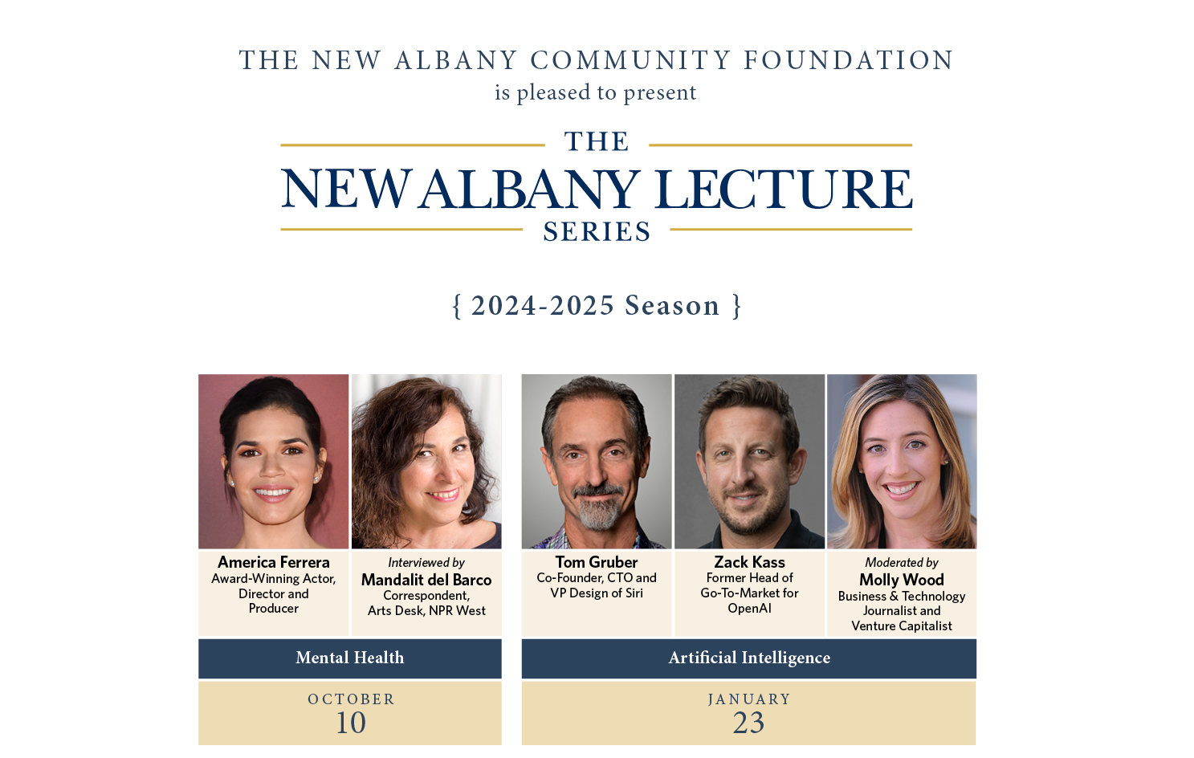

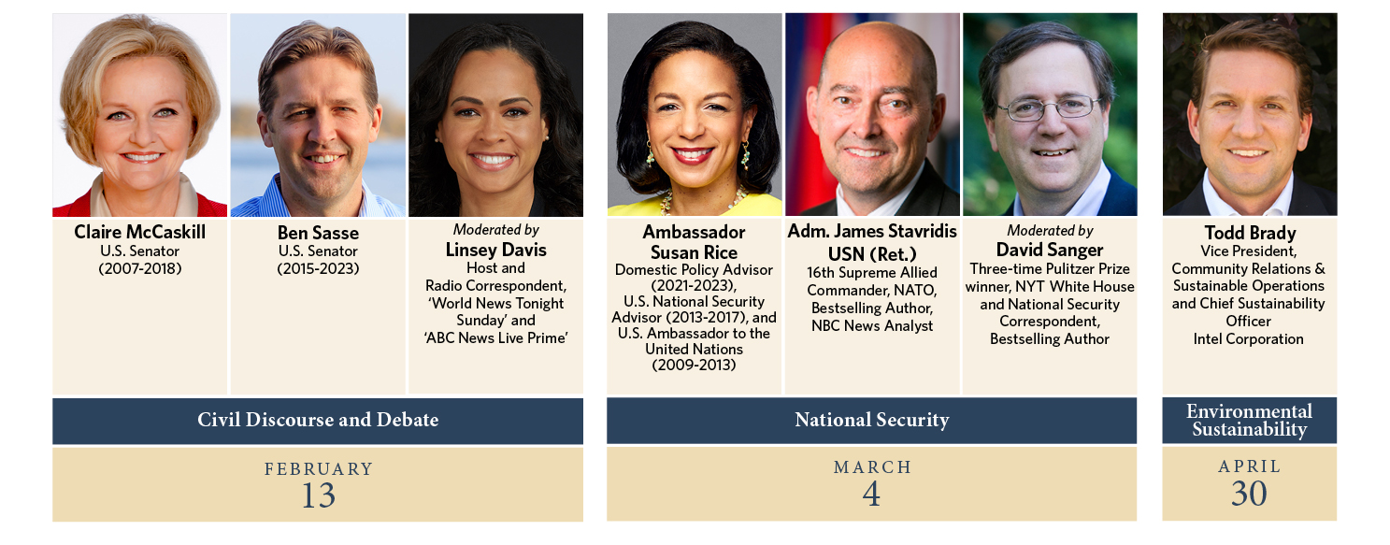
Established in 1995 by forward thinking community leaders who wanted to advance community aspirations in perpetuity, The New Albany Community Foundation focuses on initiatives that enrich the community in the areas of lifelong learning, health and wellness, the arts and environmental sustainability. Remarkable Evening proceeds along with other contributions from families and organizations have made it possible for the Foundation to award over $23 million in grants to area not-for-profit organizations that enrich lives and to make investments in transformational community initiatives such as the New Albany Branch Library, the Jeanne B. McCoy Community Center for the Arts, the Charleen & Charles Hinson Amphitheater, Healthy New Albany, New Albany Safety Town Program, the school Author Residency Program and more.

###

